To obtain the audio features in the form of the Fpy.mat file that we import into python for further processing, you should run the matlab file “Final_feature_extractor.mlx” using these steps. Make sure you are in the directory “feature_extraction”.

1. Add some wav files to the folder “datafiles”

2. Set pyenv by inserting the path to your python executable (the output of “which python” in your command prompt) between the “” in: pyenv("Version”, “”).

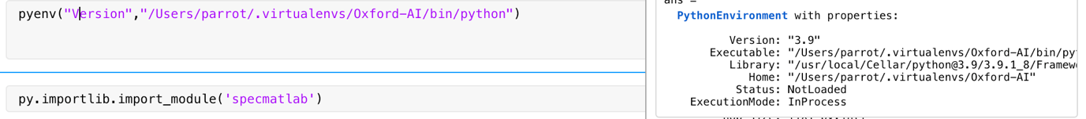

3. Run “pip install -r requirements.txt”

4. Run all the other lines.

Notes:

1. “Fpy.mat” is the file with audio features
2. The training text file “nn_ele_hb_00-24hr_TrainingSet_v2.txt” should be in the directory
3. “specmatlab.py” is the python script that extracts the audio files which we then import into matlab for processing